ITA0435 – STATISTICS WITH R PROGRAMMING FOR VISUALIZATION
NAME : R.SABARISH
REG NO ; 192324092
UNIT III WORKING WITH DATA FRAMES, FILE OPERATIONS IN R
1.STUDENT ACADEMIC RECORDS MANAGEMENT
# STUDENT ACADEMIC RECORDS MANAGEMENT SYSTEM (Without reshape2)

# 1. Create Sample Student Data Frames

cse <- data.frame(
Student_ID = c(101, 102),
Name = c("Arun", "Meena"),
Department = "CSE",
Semester = c(5, 5),
Math = c(85, 78),
Physics = c(88, 74),
Chemistry = c(80, 70)
)

ece <- data.frame(
Student_ID = c(201, 202),
Name = c("Kiran", "Divya"),
Department = "ECE",
Semester = c(5, 6),
Math = c(75, 82),
Physics = c(79, 85),
Chemistry = c(72, 88)
)

it <- data.frame(
Student_ID = c(301, 302),
Name = c("Rahul", "Sneha"),
Department = "IT",
Semester = c(6, 6),
Math = c(90, 86),
Physics = c(92, 89),
Chemistry = c(89, 84)
)

# 2. Display Structure
cat("Structure of CSE Data:\n")
str(cse)

# 3. Merge All Departments
all_students <- rbind(cse, ece, it)

cat("\nCombined Data:\n")
print(all_students)

# 4. Subject-wise Performance (Mean Marks)
cat("\nSubject-wise Average Marks:\n")
print(colMeans(all_students[, 5:7]))

# 5. Edit Specific Row and Column
all_students$Math[all_students$Student_ID == 101] <- 95
all_students$Semester <- all_students$Semester + 1

cat("\nUpdated Data:\n")
print(all_students)

# 6. Save to New CSV File
write.csv(all_students, "Updated_Student_Records.csv", row.names = FALSE)

cat("\nFile Saved Successfully!\n")
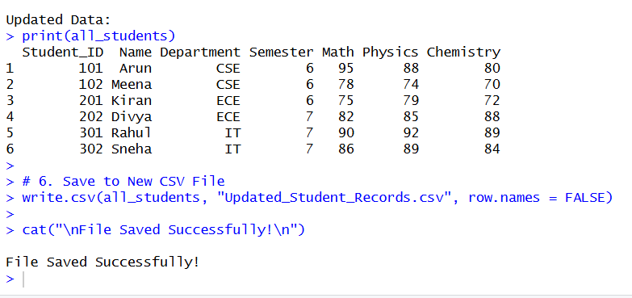
2. HOSPITAL PATIENT DATA ANALYSIS
# HOSPITAL PATIENT DATA ANALYSIS SYSTEM

# 1. Create Admission Data Frame
admission_data <- data.frame(
Patient_ID = c(1, 2, 3, 4),
Name = c("Arun", "Meena", "Rahul", "Divya"),
Age = c(45, 30, 50, 28),
Diagnosis = c("Diabetes", "Fever", "Heart", "Asthma")
)

# Create Billing Data Frame
billing_data <- data.frame(
Patient_ID = c(1, 2, 3, 4),
Treatment = c("Insulin", "Medication", "Surgery", "Inhaler"),
Treatment_Cost = c(5000, 2000, 15000, 3000)
)

# 2. Merge Admission and Billing Data using Patient_ID
hospital_data <- merge(admission_data, billing_data, by = "Patient_ID")

cat("Merged Hospital Data:\n")
print(hospital_data)

# 3. Reshaping Data (Wide to Long and Long to Wide)

# Create Wide Format Example (Multiple Costs)
hospital_data$Lab_Cost <- c(1000, 500, 3000, 700)
hospital_data$Medicine_Cost <- c(1500, 800, 4000, 900)

cat("\nWide Format Data:\n")
print(hospital_data)

# Convert Wide → Long using base R (stack)
long_data <- stack(hospital_data[, c("Treatment_Cost", "Lab_Cost", "Medicine_Cost")])
long_data$Patient_ID <- rep(hospital_data$Patient_ID, 3)

cat("\nLong Format Data:\n")
print(long_data)

# Long → Wide using reshape
wide_data <- reshape(
long_data,
idvar = "Patient_ID",
timevar = "ind",
direction = "wide"
)

cat("\nConverted Back to Wide Format:\n")
print(wide_data)

# 4. Filter and Edit Records

# Filter patients with treatment cost > 4000
high_cost_patients <- hospital_data[hospital_data$Treatment_Cost > 4000, ]

cat("\nHigh Cost Patients:\n")
print(high_cost_patients)

# Update treatment cost for Patient_ID 2
hospital_data$Treatment_Cost[hospital_data$Patient_ID == 2] <- 2500

cat("\nUpdated Hospital Data:\n")
print(hospital_data)

# 5. Write Processed Data to New CSV File
write.csv(hospital_data, "Processed_Hospital_Report.csv", row.names = FALSE)

cat("\nProcessed data saved as 'Processed_Hospital_Report.csv'\n")

# Example: Reading from CSV (if file exists)
# read_data <- read.csv("hospital_data.csv")
# str(read_data)
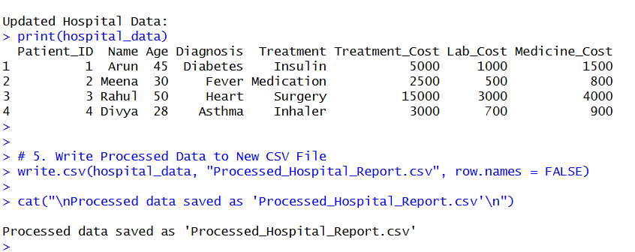
3. E-COMMERCE SALES DATA PROCESSING
# ===============================================
# E-COMMERCE SALES DATA PROCESSING SYSTEM
# ===============================================

# ------------------------------------------------
# 1. Create Sample Sales Data (Simulating CSV files)
# ------------------------------------------------

sales_day1 <- data.frame(
Product_ID = c(101, 102, 103),
Date = as.Date(c("2024-03-01","2024-03-01","2024-03-01")),
Region = c("North","South","East"),
Sales_Amount = c(5000, 3000, 4000)
)

sales_day2 <- data.frame(
Product_ID = c(101, 102, 103),
Date = as.Date(c("2024-03-02","2024-03-02","2024-03-02")),
Region = c("West","North","South"),
Sales_Amount = c(4500, 3500, 3800)
)

# Combine multiple files (like reading multiple CSVs)
sales_data <- rbind(sales_day1, sales_day2)

cat("Combined Sales Data:\n")
print(sales_data)

# ------------------------------------------------
# 2. Create Product Information Data
# ------------------------------------------------

product_info <- data.frame(
Product_ID = c(101, 102, 103),
Product_Name = c("Laptop", "Mobile", "Headphones"),
Category = c("Electronics", "Electronics", "Accessories")
)

# Merge safely using common column
merged_data <- merge(sales_data, product_info, by = "Product_ID")

cat("\nMerged Sales + Product Data:\n")
print(merged_data)

# ------------------------------------------------
# 3. Melting (Wide → Long Format Example)
# ------------------------------------------------

wide_sales <- data.frame(
Product_ID = c(101, 102),
North = c(5000, 3000),
South = c(4000, 3500),
East = c(4500, 3200),
West = c(4800, 3100)
)

cat("\nWide Sales Data:\n")
print(wide_sales)

# Convert Wide to Long using stack()
long_sales <- stack(wide_sales[, 2:5])
long_sales$Product_ID <- rep(wide_sales$Product_ID, 4)

colnames(long_sales) <- c("Sales_Amount", "Region", "Product_ID")

cat("\nLong Format Sales Data:\n")
print(long_sales)

# ------------------------------------------------
# 4. Casting (Region-wise Summary Table)
# ------------------------------------------------

region_summary <- aggregate(Sales_Amount ~ Region,
data = long_sales,
sum)

cat("\nRegion-wise Total Sales:\n")
print(region_summary)

# ------------------------------------------------
# 5. Modify Sales Values
# ------------------------------------------------

# Increase North region sales by 10%
long_sales$Sales_Amount[long_sales$Region == "North"] <-
long_sales$Sales_Amount[long_sales$Region == "North"] * 1.10

cat("\nUpdated Sales Data:\n")
print(long_sales)

# ------------------------------------------------
# 6. Write Final Processed Data to CSV
# ------------------------------------------------

write.csv(long_sales,
"Processed_Ecommerce_Sales.csv",
row.names = FALSE)

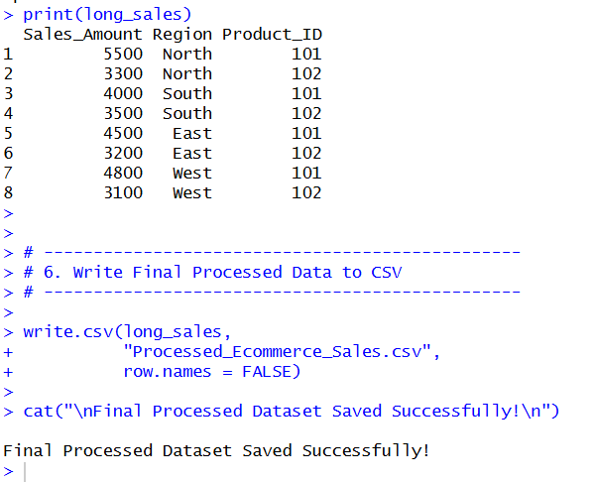
cat("\nFinal Processed Dataset Saved Successfully!\n")

4. EMPLOYEE PAYROLL MANAGEMENT SYSTEM
# ==============================================
# EMPLOYEE PAYROLL MANAGEMENT SYSTEM
# ==============================================

# ------------------------------------------------
# 1. Create Payroll Data Frame Manually
# ------------------------------------------------

payroll <- data.frame(
Employee_ID = c(1, 2, 3, 4),
Department = c("HR", "IT", "Finance", "IT"),
Salary = c(40000, 60000, 55000, 65000),
Bonus = c(5000, 7000, 6000, 8000),
Tax_Deduction = c(4000, 6000, 5000, 6500)
)

cat("Initial Payroll Data:\n")
print(payroll)

# ------------------------------------------------
# 2. Read Payroll Data from External Files
# ------------------------------------------------

# Reading from CSV file
# payroll <- read.csv("payroll.csv")

# Reading from Text file
# payroll_txt <- read.table("payroll.txt", header = TRUE)

# Reading from Excel (Requires readxl package)
# install.packages("readxl")
# library(readxl)
# payroll_excel <- read_excel("payroll.xlsx")

# ------------------------------------------------
# 3. Reshape Payroll Data (Wide → Long and Summary)
# ------------------------------------------------

# Convert Salary, Bonus, Tax into Long Format
long_payroll <- stack(payroll[, c("Salary", "Bonus", "Tax_Deduction")])
long_payroll$Employee_ID <- rep(payroll$Employee_ID, 3)
long_payroll$Department <- rep(payroll$Department, 3)

colnames(long_payroll) <- c("Amount", "Component", "Employee_ID", "Department")

cat("\nLong Format Payroll Data:\n")
print(long_payroll)

# Department-wise Salary Distribution
dept_summary <- aggregate(Salary ~ Department,
data = payroll,
mean)

cat("\nDepartment-wise Average Salary:\n")
print(dept_summary)

# ------------------------------------------------
# 4. Edit Salary or Bonus Values
# ------------------------------------------------

# Increase Salary of IT department by 10%
payroll$Salary[payroll$Department == "IT"] <-
payroll$Salary[payroll$Department == "IT"] * 1.10

cat("\nUpdated Payroll Data (After Salary Increase):\n")
print(payroll)

# ------------------------------------------------
# 5. Merge Payroll with Employee Details
# ------------------------------------------------

employee_details <- data.frame(
Employee_ID = c(1, 2, 3, 4),
Employee_Name = c("Arun", "Meena", "Rahul", "Divya"),
Location = c("Chennai", "Bangalore", "Mumbai", "Delhi")
)

merged_payroll <- merge(payroll, employee_details, by = "Employee_ID")

cat("\nMerged Payroll Data with Employee Details:\n")
print(merged_payroll)

# ------------------------------------------------
# 6. Export Final Payroll Report
# ------------------------------------------------

write.csv(merged_payroll,
"Final_Payroll_Report.csv",
row.names = FALSE)

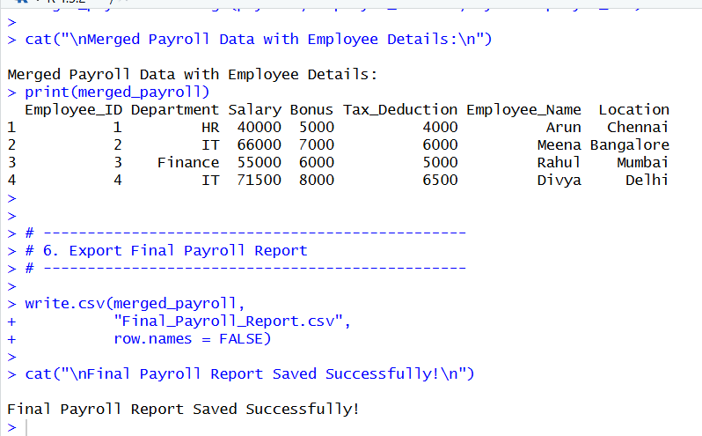
cat("\nFinal Payroll Report Saved Successfully!\n")

5. WEATHER DATA REPORTING SYSTEM
# =====================================================
# ADVERTISEMENT SPENDING AND SALES RELATIONSHIP
# =====================================================

# Sample Monthly Data for 3 Years (36 Months)

Advertisement <- c(20,22,25,30,28,35,40,38,45,50,48,55,
23,26,27,32,30,36,42,39,46,52,49,58,
24,28,29,33,31,37,43,41,47,53,51,60)

Sales <- c(200,210,230,260,250,280,310,300,340,370,360,400,
215,240,245,270,265,290,320,310,350,380,370,420,
220,250,255,275,270,295,330,315,360,390,375,430)

data <- data.frame(Advertisement, Sales)

# -----------------------------------------------------
# 1. Univariate EDA
# -----------------------------------------------------

cat("Summary of Advertisement Spending:\n")
print(summary(data$Advertisement))

cat("\nSummary of Sales Revenue:\n")
print(summary(data$Sales))

cat("\nStandard Deviation:\n")
cat("Advertisement SD:", sd(data$Advertisement), "\n")
cat("Sales SD:", sd(data$Sales), "\n")

# Histograms
hist(data$Advertisement, main="Advertisement Distribution",
xlab="Advertisement Spending")

hist(data$Sales, main="Sales Distribution",
xlab="Sales Revenue")

# -----------------------------------------------------
# 2. Covariance
# -----------------------------------------------------

cov_value <- cov(data$Advertisement, data$Sales)
cat("\nCovariance between Advertisement and Sales:\n")
print(cov_value)

# -----------------------------------------------------
# 3. Correlation Coefficient
# -----------------------------------------------------

cor_value <- cor(data$Advertisement, data$Sales)
cat("\nCorrelation Coefficient:\n")
print(cor_value)

if(cor_value > 0.7){
cat("Strong Positive Relationship\n")
} else if(cor_value > 0.3){
cat("Moderate Positive Relationship\n")
} else {
cat("Weak Relationship\n")
}

# -----------------------------------------------------
# 4. Scatter Plot
# -----------------------------------------------------

plot(data$Advertisement, data$Sales,
main="Scatter Plot: Advertisement vs Sales",
xlab="Advertisement Spending",
ylab="Sales Revenue",
pch=19)

abline(lm(Sales ~ Advertisement, data=data), col="red")

# -----------------------------------------------------
# 5. Difference Between Covariance and Correlation
# -----------------------------------------------------

cat("\nDifference Explanation:\n")
cat("Covariance measures direction of relationship but is scale dependent.\n")
cat("Correlation measures strength and direction, and is standardized between -1 and +1.\n")
